Social Studies 20-1

- National Interest and Foreign Policy
- Nationalism and Ultranationalism
ASSIGNMENT BOOKLET 2A

SENIOR HIGH SCHOOL
Fort Saskatchewan 780 992 0101
Sherwood Park 780 464 1899
Vegreville 780 632 7998

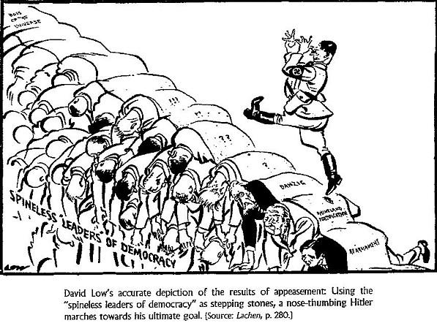

Assignment Booklet Questions Rubric 10-1/20-1/30-1

 | Excellent (5) | Proficient (4) | Satisfactory (3) | Limited (2) | Poor (1)
Communication:  Consider effectiveness of student’s:  - organization  - Syntax, mechanics, and grammar  - Use of vocabulary and Social Studies terminology | Writing is fluent and skillfully structured. Controlling idea effectively sustained and integrated. Skillfully control. Absence of error impressive. Precise, deliberate vocabulary. | Writing is clear and purposefully structured. Controlling idea coherently sustained and integrated. Capable control. Minor errors do not impede communication. Appropriate, specific vocabulary. | Writing is straightforward and functionally ordered. Controlling idea generally maintained. Basic control. Occasional lapses and minor errors, however generally clear. Conventional, adequate vocabulary. | Writing is awkward and lacks clarity. Controlling idea inconsistently maintained. Faltering control. Errors obscure the clarity of communication. Imprecise, simplistic vocabulary. | Writing is unclear and disorganized. Controlling idea is absent. Lack of control. Jarring errors impede communication. Overgeneralized, inaccurate vocabulary.
Interpretation & Analysis of Responses:  Consider how effectively the students:  - Critically analyze and demonstrate an understanding of the question | Insightful and sophisticated analysis and understanding of question. Perceptive, and comprehensively developed response. | Sound and adept analysis and understanding of question. Purposeful and capably developed response. | Straightforward and conventional analysis and understanding of question. Generalized and adequately developed response. | Analysis and understanding of question incomplete, lacks depth. Response is superficial and lacks development. | Minimal analysis and understanding of the question. Disjointed and vague response.
**IMPORTANT: Students are expected to complete ALL OF THE QUESTIONS in the assignment booklets. Booklets with less than 85% complete will be returned to the student for completion. **
Social Studies 20-1
Assignment Booklet 3: Chapter 5: National Interest and Foreign Policy
________________________________________________________
1. (Page 110) Related Issue 2

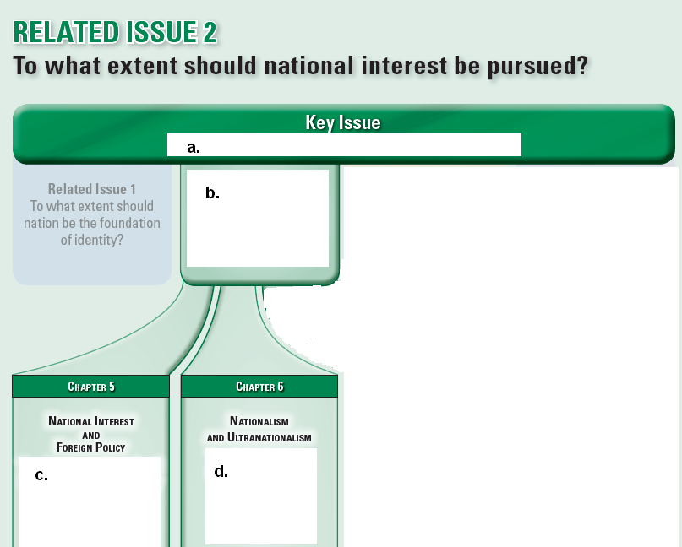

2. (Page 110) What are the three central questions that chapter 5 asks?

4. (Page 117) Aspects of National Interest

b) Define national interest:

c) What are three categories of national interest that a nation may focus on?

5. (Page 117) Changing Views of National Interest

a) Read the section. Why are national interests not static?

b) What do you think are the primary national interests for Canada?

6. (Page 118) Differing Views of National Interest

a) What do people often base their decision of what is in their national interest upon?

b) What is the difference between Canada’s role as peacekeepers and its shifting role to that of peacemaking?

c) Summarize the examples that the textbook outlines as national interests.

Condoleeza Rice,
United States

China Daily,
China

Kofi Annan,
United Nations

John Spriztler, research scientist , United States

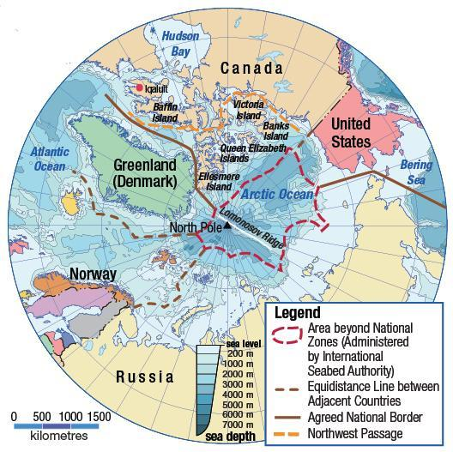

7. (Page 119) National Interest and Arctic Sovereignty

WATCH: Protecting Arctic Sovereignty: View from the North

a) National interest often involves claiming sovereignty over

b) There are two factors that have highlighted the importance of claiming sovereignty in the Arctic.
Explain why the Northwest Passage would be of national interest to several nations.

Explain the second factor that has made the Arctic an area in which several countries pursue because of their national interests.

8. (Page 122) How has national interest shaped foreign policy?
a) What is a policy?

b) Using examples, explain the differences between domestic policy and foreign
policy.

9. (Page 123) National Interest and World War I Peace Settlements
a) The textbook states: “Before World War I, nationalism had flourished in Europe. Many historians believe that nationalism and people’s beliefs about their national interest were important causes of the war.”
In this context, explain what the authors are saying about what nationalism is. You may wish to review the definitions of the sidebar on page 2.

Considering your interpretation of nationalism that you have just written, respond to the Key Issue question for the Social Studies 20-1 course, “To what extent should we embrace nationalism?”

b) (Page 123 continued) Why do you think that European governments believed that expanding their territory in Europe, as well as their colonies all over the world, was in their national interest?

c) Why would nations’ formation of alliances during World War I be considered in their national interest?

10. (Page 123) Treaty Negotiations in France
a) Read the section carefully. It is generally understood today that the Treaty of Versailles placed a disproportionately unfair share of the blame for World War One on Germany. Develop your own theory as to how the nationalist interests of some nations managed to overpower the national interests of Germany after World War One.

11. (Page 124) Woodrow Wilson: Visionary or Dreamer?

a) Under Wilson’s plan, countries would

b) The Fourteen Points did not require

c) Why do you think Germany had to accept guilt for starting the war?

d) Wilson’s proposal to create a League of Nations (which eventually led to United Nations) was acted upon, but the League had a hard time cooperating. When individuals or groups can’t cooperate, what causes that lack of cooperation?

12. (Page 126) National Interests after World War I

In point form, summarize what happened when World War I was over.

13. (Page 126) Nationalism and National Interests in the Middle East , the Map from Page 114, and the chapter introduction from Page 115
a) (Pages 114-115) Make a list of at least six of the different people groups that had all been under the huge umbrella of the Ottoman Empire from the 13th century to the end of
World War I.

b) With new-found partial independence on short notice, what would be the mixed feelings that would have emerged in these new countries?

d) (Page 126) What was the nature of the secret that was kept from Prince Emir Faysal?

e) Look carefully again at the map on page 115 and notice how the British and French have a mandate to control large portions of the Middle East. Why do you think Britain and France were in a powerful position to control the destiny of the Arabs and other
people groups? (page 125).

14. (Page 127) Treaties in the Middle East
a) From Page 126, we know that France and Britain had a secret agenda in the Middle East after World War I.
Read the paragraphs on Page 127, then explain why France and Britain pursued their own national interests in the Middle East and how the Arab nationalists reacted.
WATCH: https://www.youtube.com/watch?v=4QKIxObizXM

b) What was the purpose of the Balfour Declaration?

c) (Not in textbook) Creative Project
Here is a bit more background before you start: https://www.aljazeera.com/news/2020/6/26/palestine-and-israel-mapping-an-annexation
The conflict between the Jews and Palestine has been in progress for very many years.
You will do some online research to find at least four maps that explain the border conflicts between Palestine and Israel. You will create either one of:

→a PowerPoint with at least 5 slides (you can e-mail this to your teacher)
→ or magazine-styled article

(1) Your project must include at least four maps, and brief explanations for the
maps. Each map must also include the year that it refers to.
(2) After you have prepared the maps portion of your project must also include at least one paragraph that explains why the conflict is difficult to resolve.
(3) You must also include Bibliography of sources that you have used. List all
the websites that you consulted.
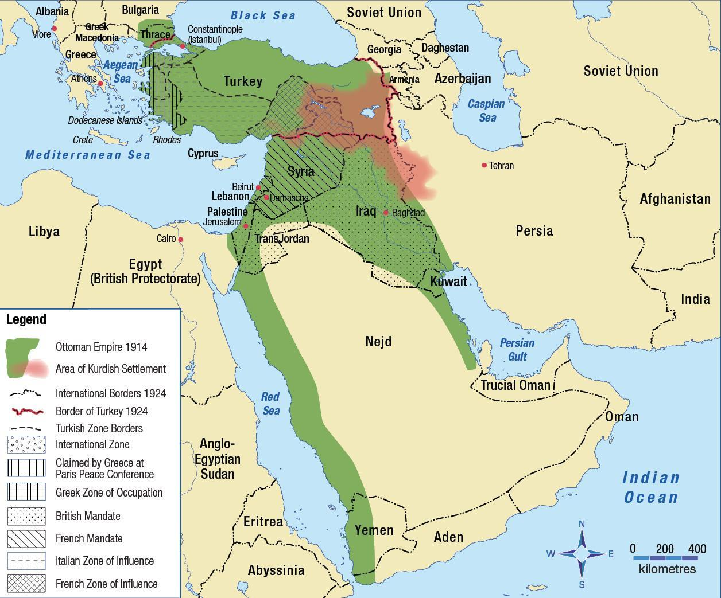

d) (Page 127 continued) and (Page 33) Mustafa Kemal Atatürk and (Page 114) Map of the Middle East before World War I

After World War I ended in 1918, the Ottoman Empire was dissolved, and new nations were created.

What kind of effect do you think the creation of new national boundaries would have had on the citizens of these new countries that were carved out of the Ottoman Empire?

What were the significant events that connect to the years in the timeline below?
1923:
1932:
1919:
1922:

1919:

1922:

1923:

1932:

Why was Atatürk so respected and loved so much?

15. (Pages 128-129) Oil and the National Interest in Iraq

Read these two pages carefully. In point form, write out 10 quick facts about what you have read. Then at the end, create two questions that analyze the situation in Iraq.

1.
2.
3.
4.
5.
6.
7.
8.
9.
10.

Question #1:

Question #2:

16. (Page 130) How has Foreign Policy Shaped National Interest?

WATCH: Foreign Policy: Crash Course Government and Politics #50

17. (Page 130) Foreign Policy and Contending National Interests in Peru

a) Fill in the diagram, and explain what the contending national interests are in Peru.

versus

Explanation: ___________________________________________________________

b) In your opinion of the issues in Peru, whose interests are more important, and why?

18. (Page 131) 9/11 and Canada in Afghanistan

a) How did Han Seung-soo justify and authorize the NATO invasion of Afghanistan?

b) How did Canada become connected to the invasion of Afghanistan, but not the invasion of Iraq?

19. (Page 132) Debate over Afghanistan

a) What was the realization that Canada and NATO allies came to, and why was it so difficult to achieve?

b) Summarize—do not directly quote—what each of the three Canadian politicians’ differing positions on Canada’s involvement in Afghanistan were.

Jack
Layton

Michael
Ignatieff

Stephen Harper

20. (Page 133) National Interests and Rights for Women and Taking Turns

a) Explain what Sima Samar was trying to achieve in Afghanistan.

b) Using the three students’ responses to guide you, answer the following question with your own opinion.

→ Has Canadian foreign policy in Afghanistan supported
the national interests of the Afghan people?

Social Studies 20-1 Chapter 6: Nationalism and Ultranationalism
________________________________________________________

21. (Pages 136-137) Nationalism and Ultranationalism

a) What is the chapter issue for Chapter 6?

b) What is the sharp irony between the poster of Stalin and how he ruled the Soviet

Union?

22. (Page 137) Key Terms

Write out the definitions of the following key terms.

ultranationalism:

propaganda:

appeasement:

conscription:

WATCH: Introduction to Propaganda

22. (Page 138) What is Ultranationalism?

a) Some people believe that nationalism is

b) People also disagree on when

c) People may agree that ultranationalism includes elements of

but

d) Would you describe Hrant Dink’s murder an act of ultranationalism? Explain your response.

23. (Page 139) Russian Ultranationalism

a) What do some people think are the causes of extreme nationalism?

How would Russia be an example of this?

b) Voices

Describe what the “very big mistake” that people make is, according to Louise Arbour.

c) Russia Under Stalin

Explain how Joseph Stalin made that “very big mistake” that Louise Arbour refers to.

24. (Page 140) Propaganda and Ultranationalism

a) Highlight the True or statements.

_____ Propaganda refers to information and ideas that are spread to achieve a
specific goal

_____ Propaganda is usually open-minded, and shows many sides of issues

_____ “propagandists” are people who spread propaganda

_____ propagandists often call their opponents names

_____ the use of propaganda usually emphasizes the real meaning of words such as
“holy” and “just”

_____ when spreading propaganda, it’s important to use respected symbols to appeal
to people’s values and beliefs, such as family images or a national flag

_____ it’s not very common for propagandists to appeal to people’s fears when trying
to make certain claims

_____ Stalin’s propagandists portrayed Stalin as a caring father of the Soviet peoples

_____ In Germany, the Nazi’s rarely used the media for propaganda, but relied upon
exposure of true crimes that Jewish persons committed

_____Goebbels was Hitler’s minister for public enlightenment and was a gifted speaker

b) Figure 6-4 and Figure 6-5

How do you think the propaganda shown in the photograph in Figure 6-4 might have influenced the treatment of Jewish people in the photograph in Figure 6-5?

25. (Pages 141-143) How does Ultranationalism Develop?

b) (Page 141) Countries in Crisis

Explain the two economic crises that are outlined in this section, and the impact that it had on peoples’ lives.

c) (Page 141) Germany after World War I

What kind of political government did Germany have after the end of World War I, and what was the problem with this government?

d) (Page 141 continued) and (Page 141) FYI

Explain several different economic difficulties that Germany had, and how these serious challenges led to the uprising of Adolf Hitler.

e) (Page 143) Joseph Goebbels

WATCH: Joseph Goebbels: The Propaganda Maestro

Read the speech that Goebbels gave. In a paragraph of 5 to 7 sentences, analyze what the subtle or hidden messages are written within this speech. Choose three direct quotes from the speech that reveal Goebbels’ true agenda.

26. (Page 144) Japan after World War I and Figure 6-7

a) How might the idea of Hirohito as being a human-god contribute to the development of ultranationalism in Japan?

b) Explain the economic crisis in Japan, and the effect it had on the Japanese citizens, and on the government.

26. (Page 145) Charismatic Leaders

Compare the similarities and contrast the differences in the leadership styles of Adolf Hitler and Tojo Hideki.

Similarities in Leadership Styles: Hitler and Hideki
They both:

Differences in Leadership Styles:

Hitler | Hideki

27. (Page 147) Instilling Ultranationalist Values

WATCH: The Interwar Period: AP European History

What are four things that the Soviet Union, Germany, Italy, and Japan had in common in the interwar years (1918-1939) and during World War II?

28. (Page 147) Ultranationalist Values in Germany

WATCH: The World Wars: Adolf Hitler | History

Propaganda is always one-sided. What is the one-sided information that German ultranationalist propaganda often focused on?

What happened to art, music and literature that did not meet these rigid requirements?

Explain why Hitler’s theory that he needed to build a “master race” was racist and discriminatory.

What happened on Kristallnacht, and what caused this horrible night?

_

29. (Page 148) Ultranationalist Values in Japan

a) What were the values that Japan promoted to increase its ultranationalist
control?

b) In point form, summarize the Japanese education system.

How was the Japanese education system similar and/or different from the education that you are part of here in Alberta?



c) (Page 148 continued) and (Page 148) Voices and Figure 6-14

What do you think happens to people when they die? (Do they go to heaven?) In two to three paragraphs, explain what you believe, then compare and contrast what you believe with what the Japanese believe about death. Explore how your beliefs affect the way you live your life, and how the Japanese live theirs.

30. (Page 149) How have People Responded to Ultranationalism?

a) Ultranationalism _______________________ all aspects of a country’s life:

b) The author of the textbook uses a very powerful word: “infects”

Use a dictionary to expand on how this word was used.

If ultranationalism is like an infection, or a disease, what do you suppose would be a good cure, or antidote? How are people supposed to respond to the “symptoms” of a disease?

c) (Page 149 continued) How have People Responded to Ultranationalism?

Ultranationalists ______________________ on people’s fears and use

______________________ to spread hatred.

What do you think people have to gain by immersing themselves in attitudes and actions of being angry and hating others?

What are some animals and birds that prey on other animals?

What is the difference between animals that prey on other animals, and humans that prey on other humans?

31. (Page 149) Appeasement as a Response to Ultranationalism and Figure 6-15

a) Define appeasement:

Tell about a time that you observed or experienced an adult using appeasement to try to get a child to stop making demands.

b) The Treaty of Versailles had been very strict and very clear—Germany was not allowed to expand its army, or expand its territory. How then, did Germany manage to achieve both as evidenced in the map in Figure 6-15?

c) What did Winston Churchill mean when he said that “an appeaser is someone who feeds a crocodile…” ?

d) (Page 149) Voices

Write a paragraph five to seven sentences long that is a personal response to Martin Neimoeller’s short poem.

32. (Page 150) Failure of the League of Nations

The League of Nations was a group of nations that agreed to meet, discuss, and act upon world problems. What had this group decided would be their responsibilities, and why did they fail?

33. (Page 150) Ethiopia and Figure 6-16

a) How was Mussolini very similar to Hitler?

c) Using trade sanctions is a refusal to buy a country's goods, and a refusal to sell goods to them. Why did the trade sanctions against Italy fail?

d) (Page 150 continued) In the 1930s, Germany, Japan, and Italy expanded their territory in pursuit of ultranationalist goals while the world did little but watch. Do you think World War II could have been prevented if Canada and other countries had responded more forcefully? Give reasons for your opinion.

33. (Page 151) War as a Response to Ultranationalism

What were the final events in September 1939 that are considered to be the official start for World War II?

34. (Page 151) Total War

What are some of the elements of “total war”?

35. (Page 152) Conscription in Canada

What does conscription mean, and why was it felt necessary to use it in Canada?

36. (Page 152) Figure 6-19

There was some significant suspicion that Japanese-Canadians, who already had Canadian citizenship, would pose a problem to Canada when Japan entered World War II by bombing the United States.

Since we know that Japanese-Canadians served in the Canadian armed forces, what kind of national loyalties did people like Takahashi and Iwaasa prove?

37. (Pages 152-153) Internment in Canada

a) What does internment mean?

b) (Pages 152-153) Internment in Canada

Explain how the internment of the Japanese-Canadians during World War II could be interpreted as being ultranationalistic?

38. (Page 153) Joy Kogawa: Shedding Light on a Shameful Story

In point form, summarize this section with ten quick facts.

PLEASE SUBMIT YOUR MODULE TO
BRIGHT SPACE & COMPLETE MODULE 2B!

